Abstract

This experiment demonstrates the design of an analog audio equalizer and volume control integrated with an amplifier. An audio equalizer adjusts the frequency content of the audio to the listener’s preference and a volume control sets the overall loudness. The audio equalizer in this experiment utilized three bands, which consisted of three filters - the bass filter, mid filter, and the treble filter - to control different ranges of frequency with adjustable gain. Equalizers are implemented using hardware or software and in this experiment, RC filters and operational amplifier circuits were used. Resistance and capacitance values were calculated to meet volume specifications at various frequencies.

The results demonstrated the use of potentiometers to control the current flowing through the circuit, thereby controlling the voltage amplitude and thus the volume of the system. Furthermore, each filter passed its corresponding frequency range to meet the specifications. This experiment is useful because audio equalizers and volume control are pertinent in all aspects of society. Audio equalizer and volume control are implemented ubiquitously from smart phones to professional high-grade audio equipment. Understanding the electrical components that drive these features are important to further innovate these devices.

Equipment Utilized

* Analog Discovery 2 (AD2)
* Waveforms Software
* Digital Multimeter
* Breadboard
* Carbon Resistors
* Ceramic Capacitors
* Inductors
* Potentiometers
* Integrated Circuit LF356N
* Integrated Circuit LM324N

Theory

Filters are circuits that are used in audio equalizer equipment to enhance certain frequencies and diminish others. In this lab, three filters are utilized to resemble an audio equalizer. A low pass filter, mid pass filter, and a high pass filter. The low pass filter, as the name suggests, passes low frequencies, specifically those up to 320 Hz. Therefore, it accentuates the bass. In contrast, the mid pass filter passes middle frequencies, specifically those between 320Hz and 3200 Hz. The high pass filter passes high frequencies, specifically those over 3200 Hz and it accentuates the treble notes. Each of these frequencies mentioned above are referred to as the cut off frequency, $f_{c}$. The cut off frequency can be determined by the resistance (R) and capacitance (C) values in the filter circuit. The equation to determine these values are shown below in equation 1.

$$RC=\frac{1}{2πf_{c}}$$

$$Equation 1: RC filter equation$$

In electronic circuit theory, gain is ability of a circuit to increase the output signal from the input. Therefore, a gain greater than one results in amplification of the input signal, where the output is louder than the input. Gain can be used as a general term for various electrical properties like current and power, but this task will refer to gain as voltage gain. In this task, the gain of the input signal will be achieved with an operational amplifier. In its most basic definition, an operational amplifier is a device that amplifies voltage. The equation for gain is given below in equation 2.

$$Gain= \frac{V_{out}}{V_{in}}$$

$$Equation 2:Gain$$

Alternating Current (AC) signals oscillate over time. One example of an AC signal is a sine wave. These signals have multiple properties, like amplitude, which is the height of the wave from its center. Moreover, period T, which is measured in seconds, is the time it takes for the wave to return to the same point it started. This is distance is called one wavelength. Additionally, the frequency, w, is the reciprocal of the period T, and measured in hertz (Hz). Double the amplitude of the signal is referred to as peak-to-peak voltage. For example, a sine wave can have an amplitude of 500 mV (peak to peak of 1V) with a frequency of 100Hz.

Instead of using amplitude to characterize a time varying sine wave, root mean square (RMS) can be used. Root mean square equally portrays an AC signal as a DC signal. Root mean square is a mathematical operation – taking a square root of the square of the mean. The equation is shown below for a cosine function in equation 3.

$$V_{rms}=\sqrt{\frac{1}{T}\int_{0}^{T}{{V^{2}}_{amplitude}\cos\left(wt\right)dt}}→V_{RMS}=\frac{V_{peak-peak}}{2\sqrt{2}}$$

$$Equation 3:RMS to peak-peak conversion$$

Error will naturally occur due to the slight inaccuracies and limitations of the measurement devices. The error between the measured values and the theoretical values can be calculated using *Equation 4* below.

$$percent error=\frac{\left|measured value-theoretical value\right|}{theoretical value}*100\%$$

*Equation 4: Percent Error*

Experiment Tasks

14.5.1 Tasks

Objective

This task will demonstrate high pass, mid pass, and low pass filters through the use of integrated circuits as amplifiers to output audio.

Procedures

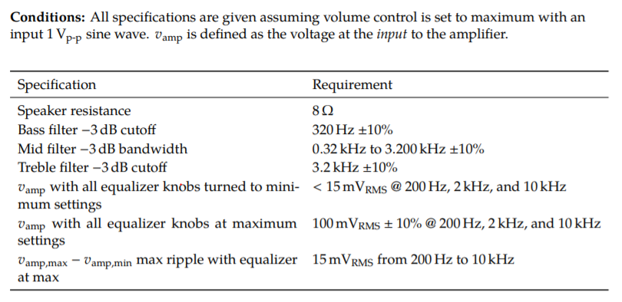

Fig 1. Specifications for the experiment[1]

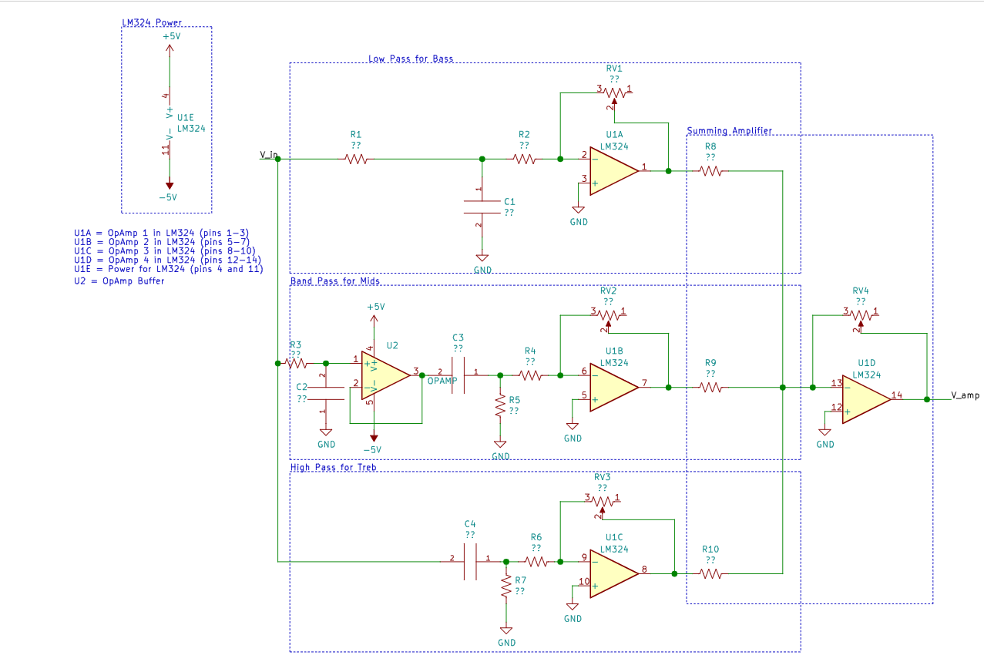

**Fig 2.** Topology of audio amplifier[2]

1. Use the topology given above in Figure 2 to calculate the component values using equations from the theory section.
2. Construct and test the amplifier and volume control subsystems on a breadboard and utilizing the waveforms network and scope features.
3. Construct and test each filter independently on a breadboard and utilizing the waveforms network and scope features.
4. Generate plots that demonstrate the specifications as shown in Figure 1 by using the snipping tool screenshot feature.

Results

1. Calculate the required component values and verify those components are available to you. Some components not in your kit are available for you to use.

The main equation used to calculate the resistance and capacitance values was equation 1: $RC=1/(2πf_{c})$.

RV1 = RV2 = RV3 = 10kΩ since they are potentiometers

$R_{1}=100Ω R_{3}=100Ω R_{5}=122Ω R_{7}=110Ω$ These resistance values were set at 100 $Ω$ then changed to meet the specifications.

Utilizing equation 1 and the resistance values above, the corresponding capacitances were calculated:

$$C_{1}=\frac{1}{2π(320Hz)(100Ω)}=5.0x{10}^{-6}F→4.7x{10}^{-6}F$$

$$C_{2}=\frac{1}{2π(3200Hz)(100Ω)}=5.0x{10}^{-7}F→4.7x{10}^{-7}F$$

$$C_{3}=\frac{1}{2π\left(320Hz\right)\left(122Ω\right)}=4.1x{10}^{-6}F→4.7x{10}^{-6}F$$

$$C_{4}=\frac{1}{2π(3200Hz)(110Ω)}=4.5x{10}^{-7}F→4.7x{10}^{-7}F$$

To control the output signals of each pass, $R_{8}=R_{9}=R_{10}=50kΩ$

To set a gain of one over each op amp, $R_{2}=R_{4}=R_{6}=10kΩ$

1. Compute the supply voltage necessary for the amplifier:
   1. What is the gain of the amplifier?

From the datasheet of the 386 chip, the gain was found to be 20.

* 1. What is the output voltage peak to peak when the input is 100 ${mV}_{RMS}$?

Using equation 2: $Gain=20=\frac{output}{100mV_{RMS}}, output=20*100mV_{RMS}=2V_{RMS}$

Using equation 3:

* 1. What supply voltage does the datasheet say will support this output range with an 8 Ω load?

According to the datasheet, approximately 8V will be supported.

1. Make the following measurements
   1. Frequency responses of all filters.

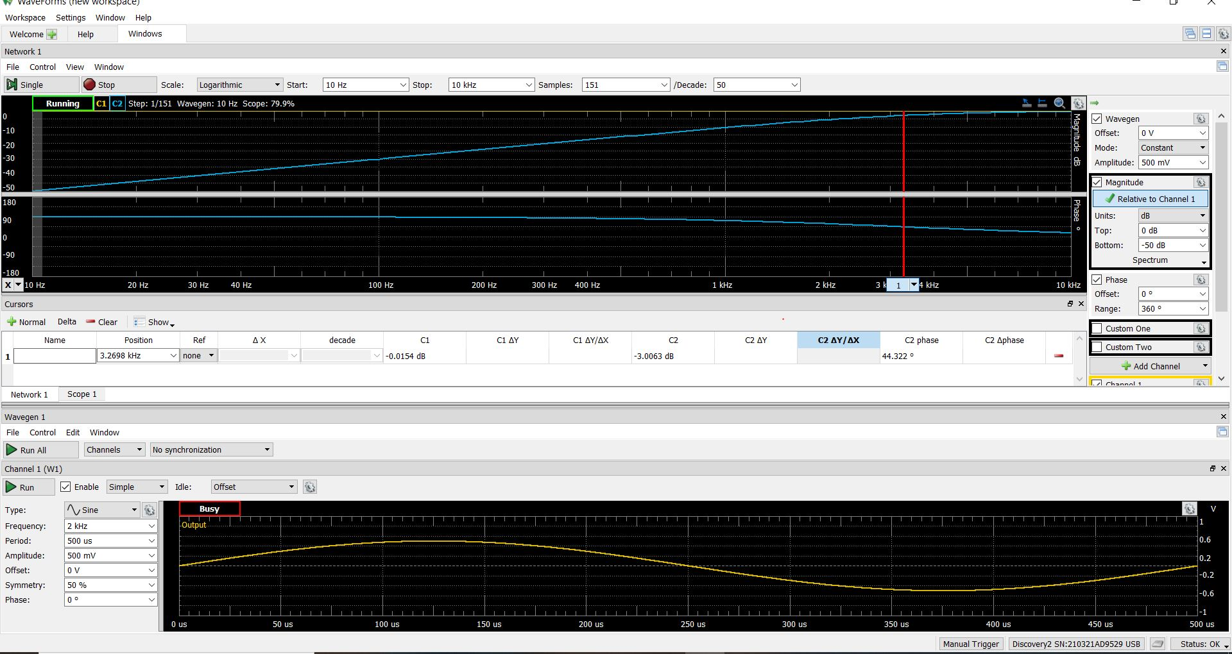

**Fig 3.** High pass filter frequency response

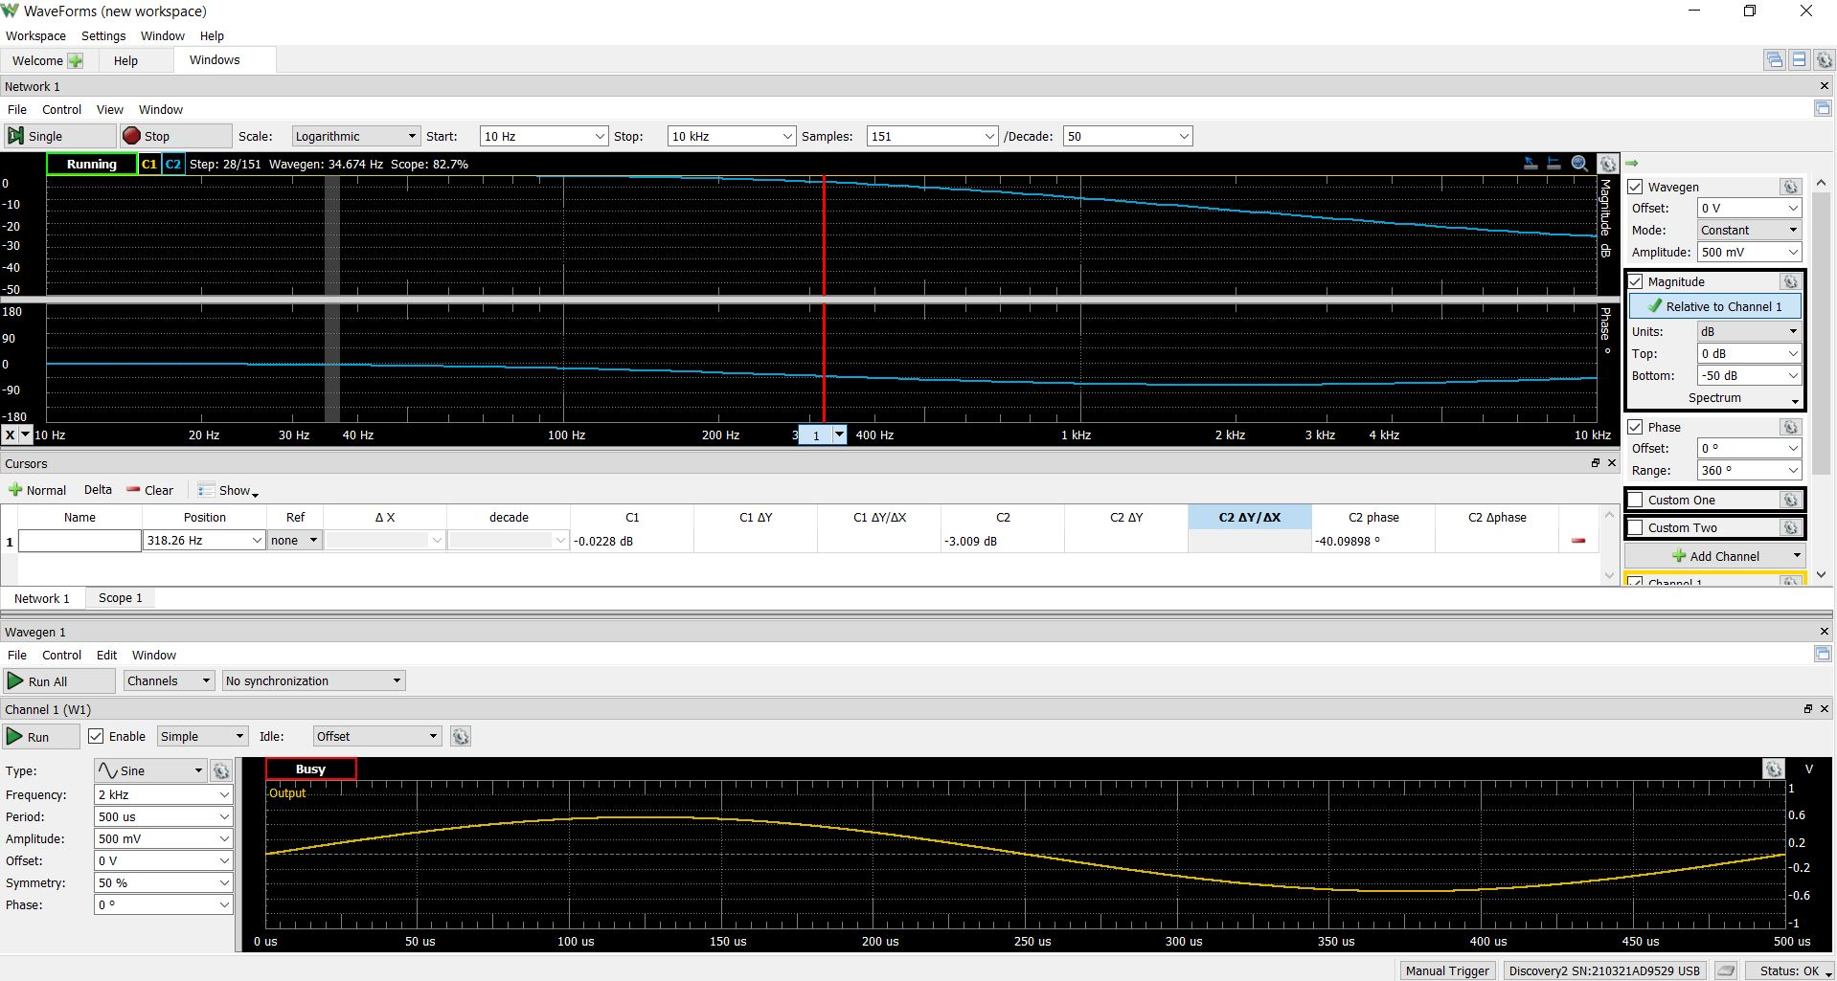

**Fig 4.** Low pass filter frequency response

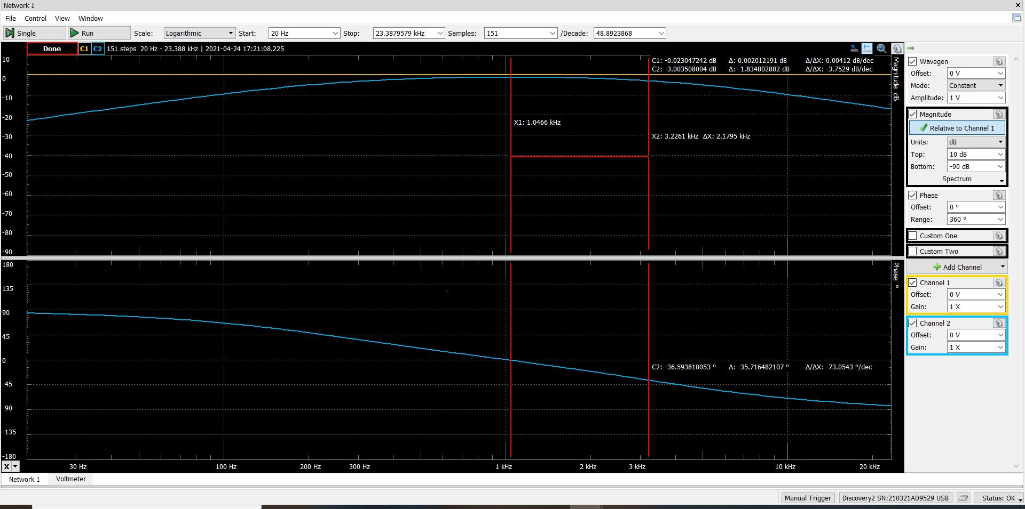

**Fig 5.** Mid pass filter second -3dB frequency response

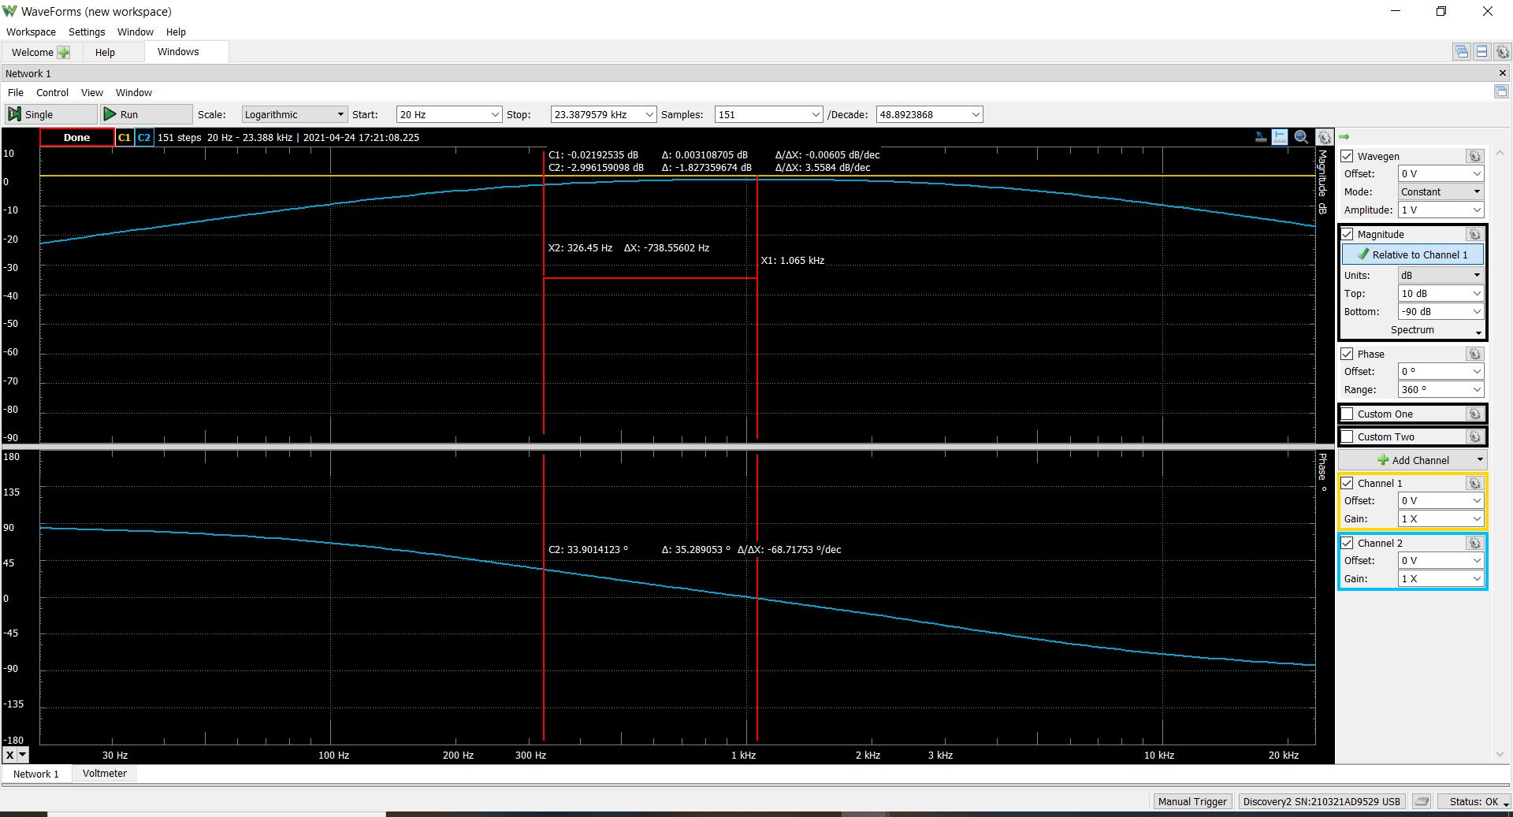

**Fig 6.** Mid pass filter first -3dB frequency response

Table I. Frequency response measurements

|  |  |  |  |  |
| --- | --- | --- | --- | --- |
| **Filter** | **Corresponding Figure** | **Measured Frequency Response at -3dB (Hz)** | **Theoretical Frequency Response at -3dB (Hz)** | **Percent error (%)** |
| High Pass Filter | 3 | 3269.8 | 3200 | 2.2 |
| Low Pass Filter | 4 | 318.3 | 320 | 0.5 |
| Mid pass – high pass component | 5 | 3226.1 | 3200 | 0.8 |
| Mid pass – low pass component | 6 | 326.5 | 320 | 2.0 |

**All of the frequency responses meets the specifications since the values are less than 10% error.**

The percent error was calculated using equation 4

* 1. A plot or plots that demonstrate the adder

To demonstrate the adder, the principle of superposition was utilized. Superposition is briefly described in the theory section of this report. First, an input triangle wave was generated, as shown below in Figure t. Secondly, another input sine wave was generated, as shown in Figure s. The first wave was inputted through the high pass and the second wave through the mid pass. The output of the combination of the two waves is shown below in Figure u.

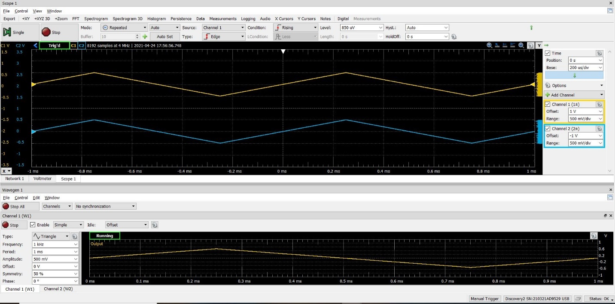

**Fig 7.** Wavegen plot of a triangle wave of frequency 1kHz.

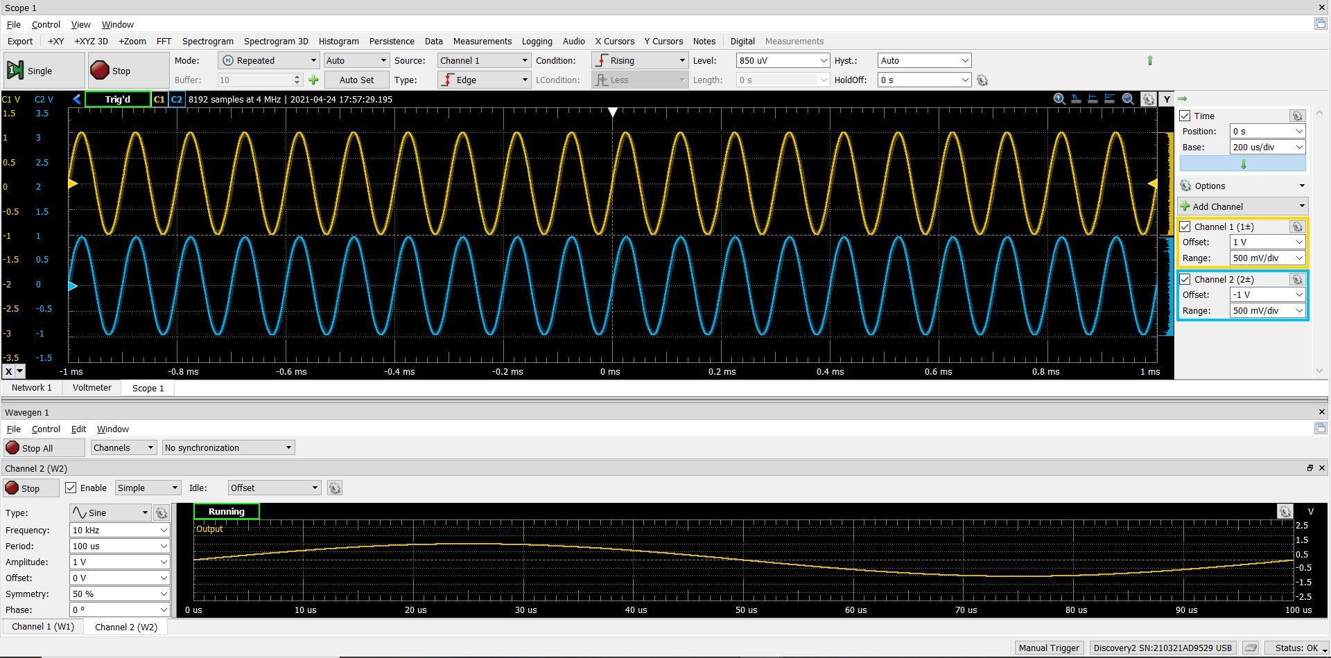

**Fig 8.** Wavegen plot of a sine wave of frequency 10kHz.

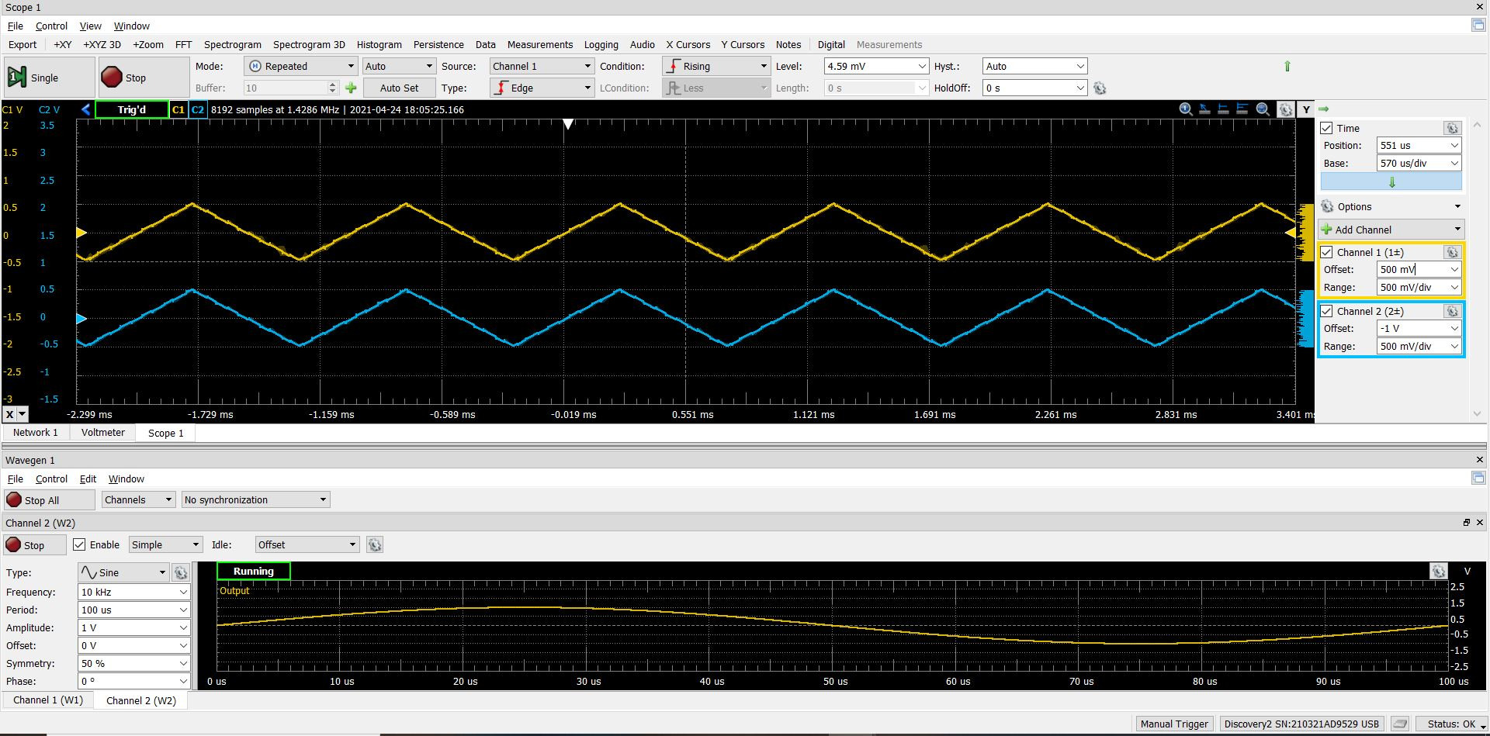

**Fig 9.** The combination of the previous two plots. The slight sinusoidal curves along the triangle edges demonstrate the adder via the superposition principle.

* 1. A plot or plots that demonstrate low, medium, and high total volume.

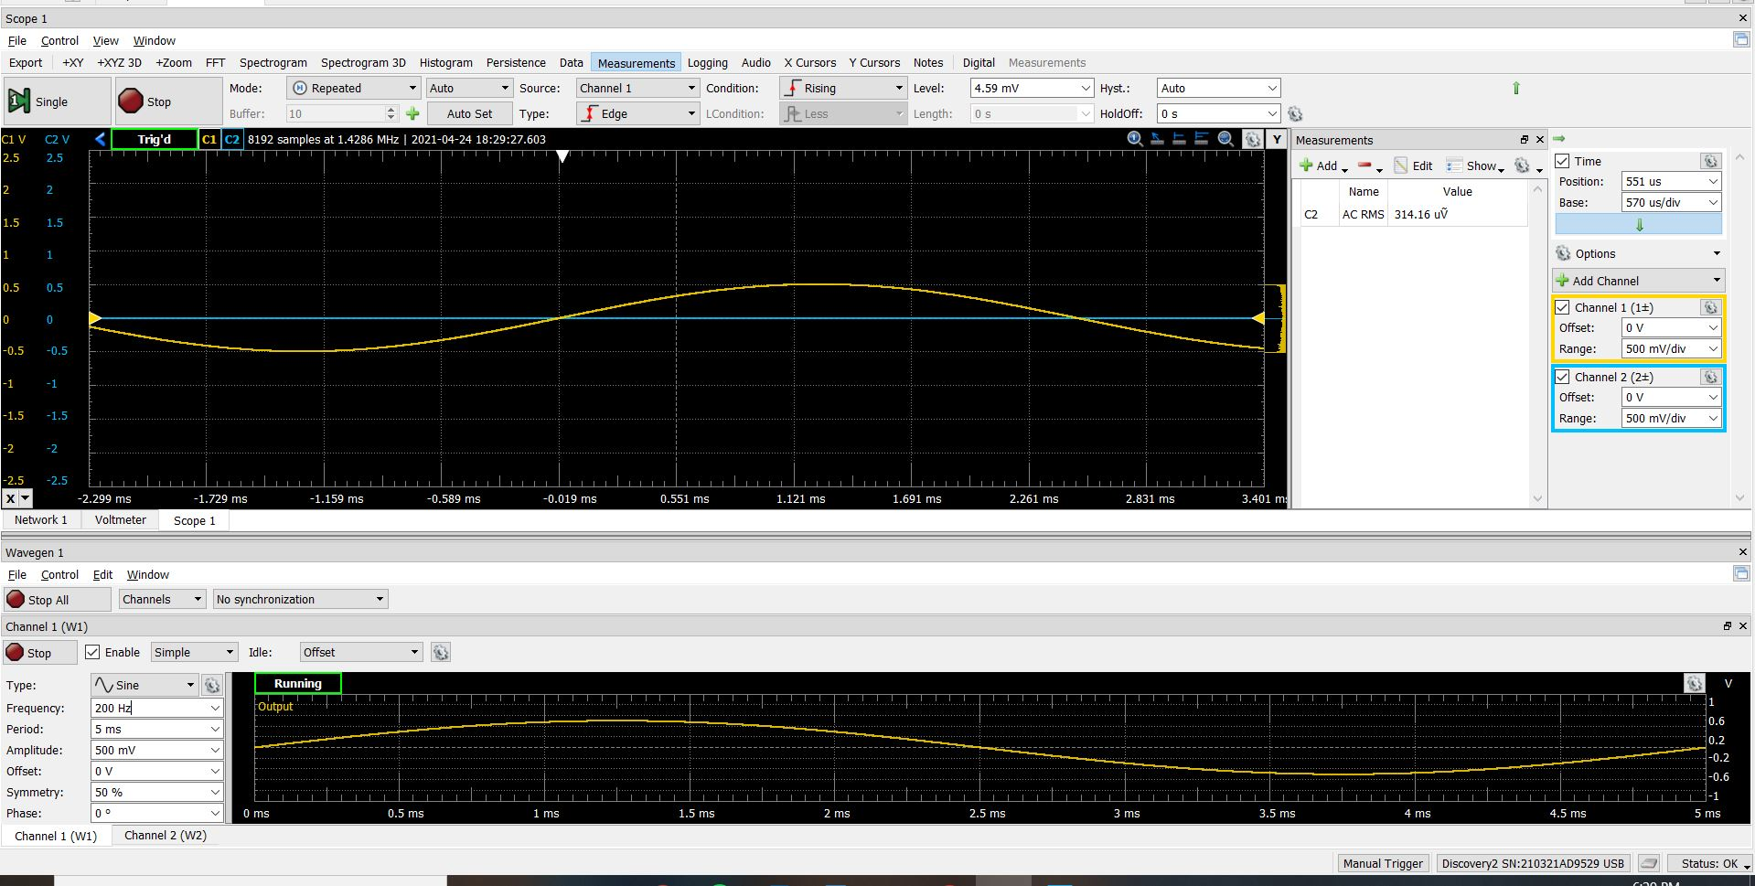

**Fig 10.** The low volume at 200Hz is 314 $μV_{RMS}$ and meets the specifications of less than 15 m $V_{RMS}$

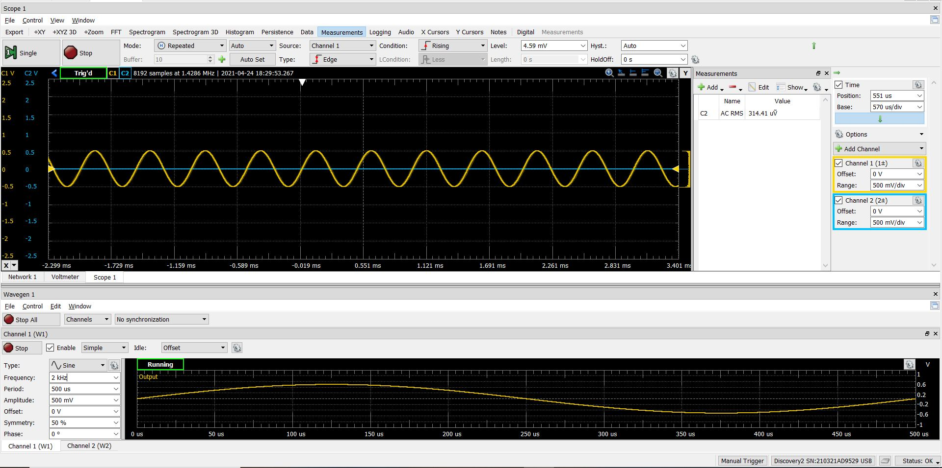**Fig 11.** The low volume at 2 kHz is 314 $μV_{RMS}$ and meets the specifications of less than 15 m $V_{RMS}$

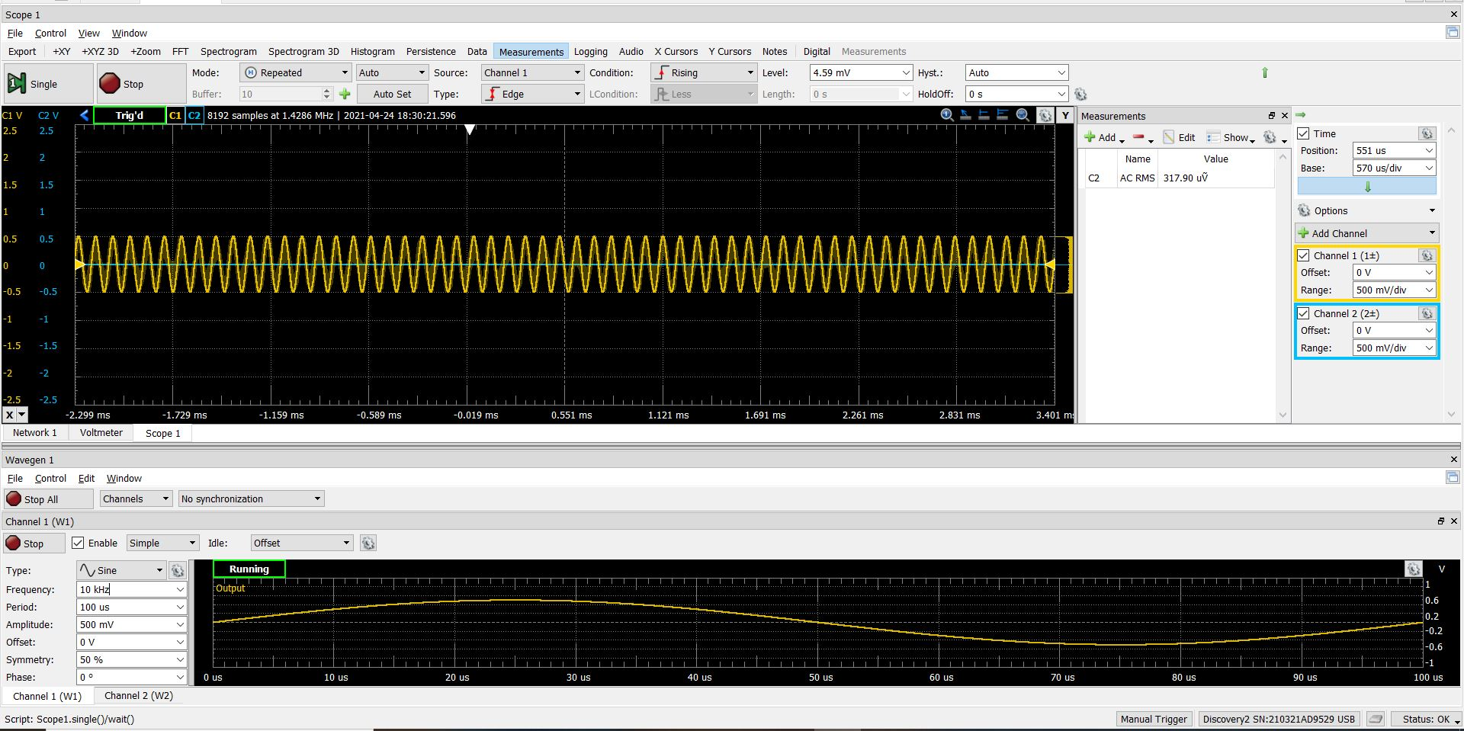

**Fig 12.** The low volume at 10 kHz is 318 $μV_{RMS}$ and meets the specifications of less than 15 m $V_{RMS}$

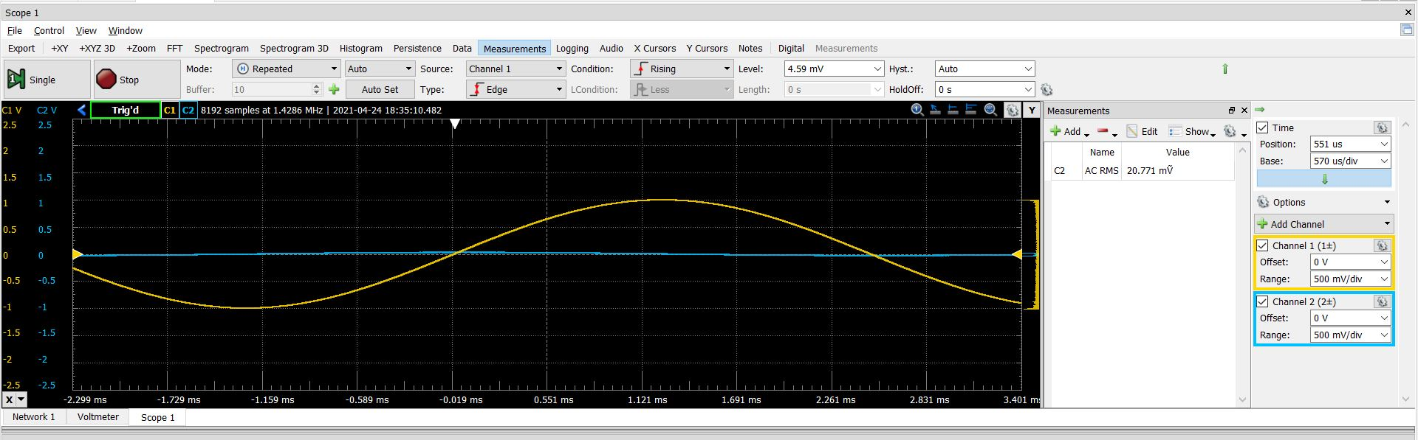

**Fig 13.** The medium volume at 200Hz is 21 m $V_{RMS}$ and meets the specifications of between 15 m $V_{RMS}$ and 100 ${mV}_{RMS}$

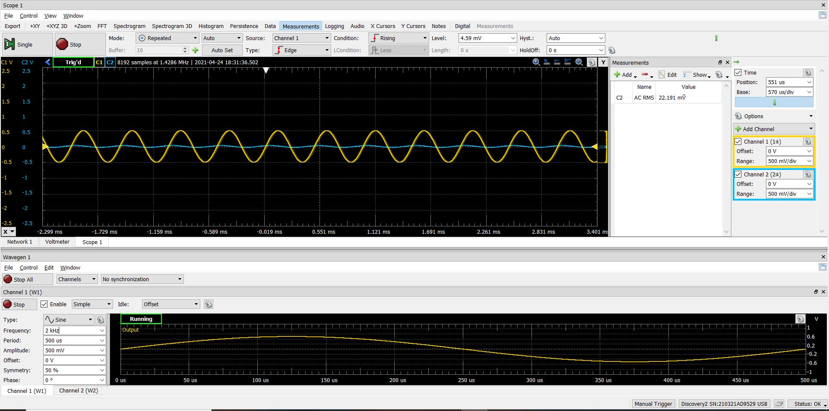

**Fig 14.** The medium volume at 2 kHz is 22 m $V_{RMS}$ and meets the specifications of between 15 m $V_{RMS}$ and 100 ${mV}_{RMS}$

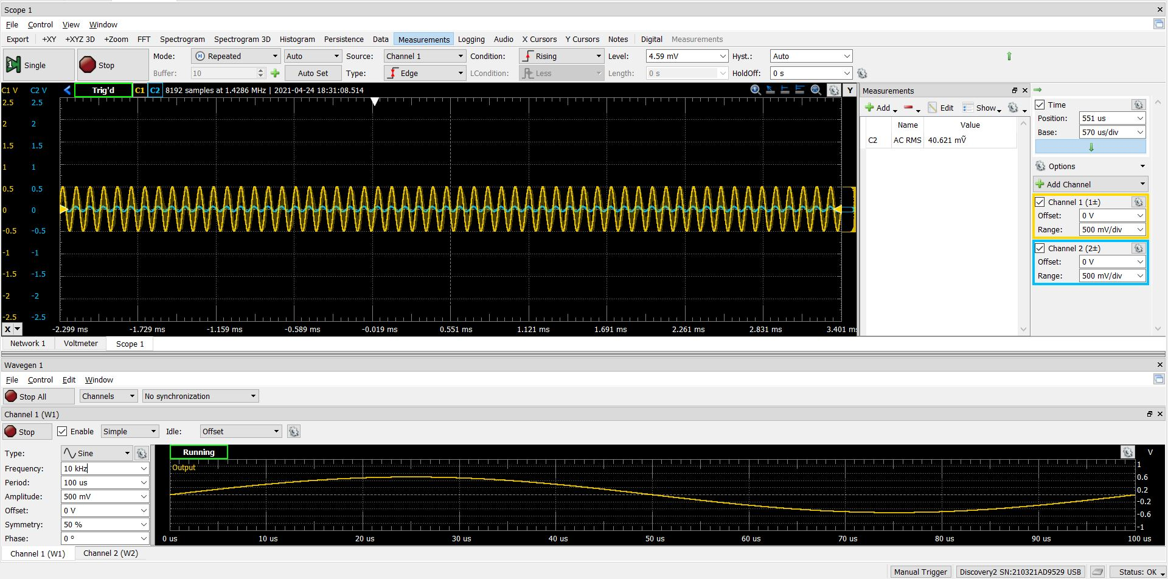

**Fig 15.** The medium volume at 10 kHz is 41 m $V_{RMS}$ and meets the specifications of between 15 m $V_{RMS}$ and 100 ${mV}_{RMS}$

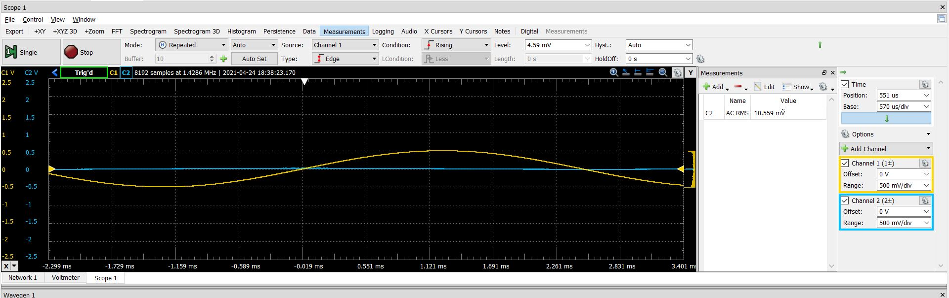

**Fig 16.** The high volume at 200 Hz is 11 m $V_{RMS}$ and did not meet the specification of 100 m $V_{RMS}$

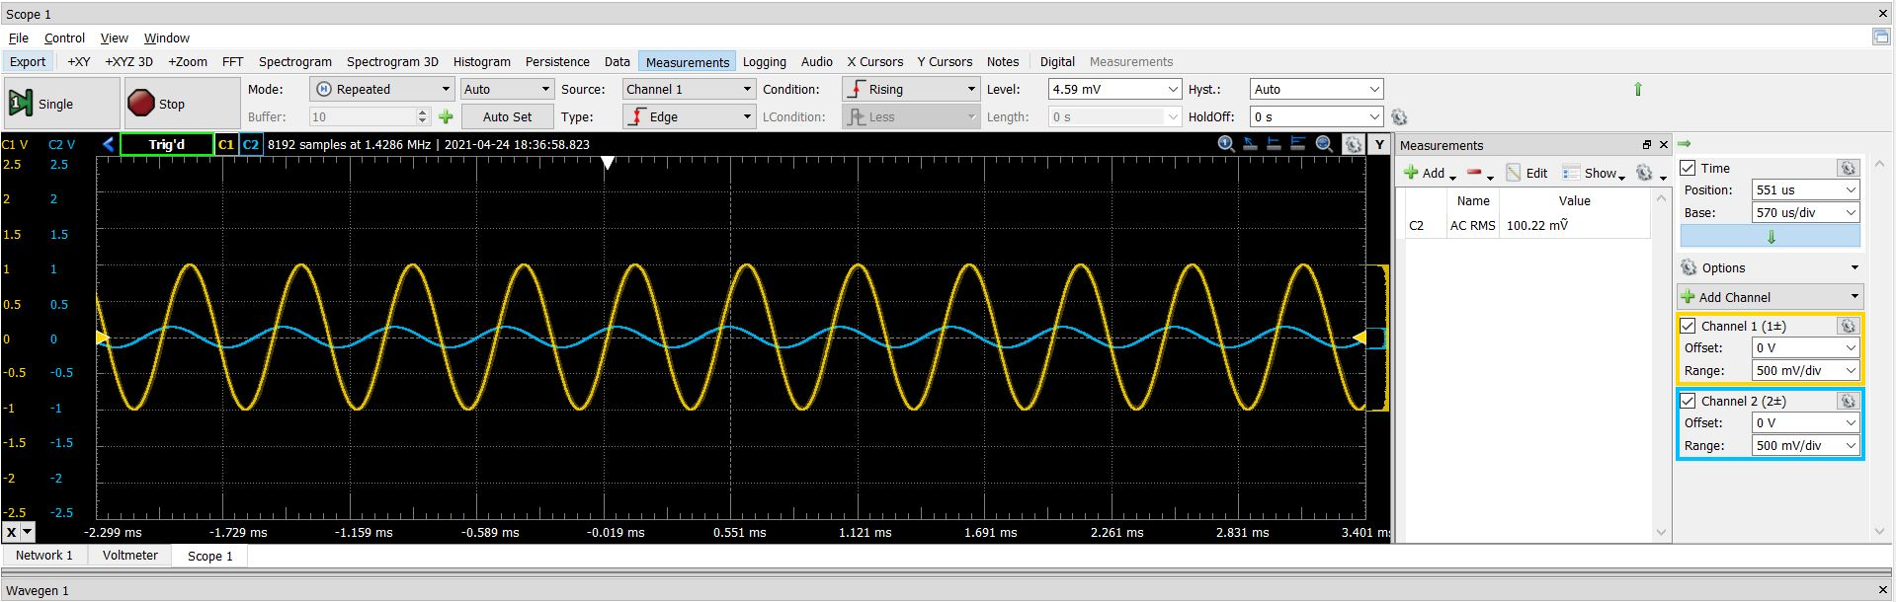

**Fig 17.** The high volume at 2 kHz is 100 m $V_{RMS}$ and meets the specification of 100 m $V_{RMS}$

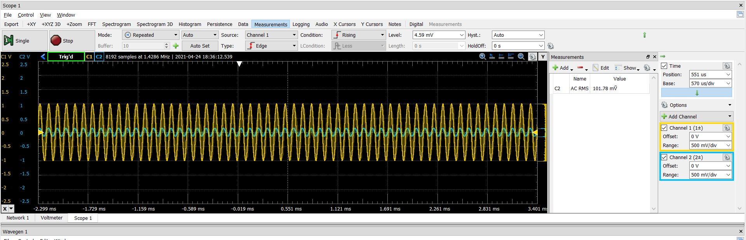

**Fig 18.** The high volume at 10 kHz is 102 m $V_{RMS}$ and meets the specification of 100 m $V_{RMS}$.

Conclusions

All of the plots generated in this experiment met the specifications posed in the procedures section, with the 200Hz high volume plot being the only exception. The frequency responses of the low, mid, and high pass filters all were within 2 percent error of the needed values. The frequency response plots correctly passed the right frequency of signals, with the low pass passing low frequencies, mid pass passing middle frequencies, and the high pass passing high frequencies. Moreover, by turning the volume control of the potentiometers, the amplitude of the output signal increased at higher volumes and decreased at lower volumes. This task demonstrated the audio equalizer characteristics through the use of these filters. Because of the relatively low error, and nearly all plots producing correct results, this task was a success.

1. A. Balmos and S. Hathorn, *Electrical Engineering Fundamentals Laboratory I*. 2019.
2. A. Balmos and S. Hathorn, *Electrical Engineering Fundamentals Laboratory I*. 2019.